- IDENTIFICATION OF GPU MODEL INSTALLED IN A PC

- INTRODUCTION:

A Graphics Processing Unit (GPU) is a hardware component responsible for rendering images, videos, animations, and 3D graphics. It improves gaming performance, video editing, graphic designing, and AI-related tasks. GPUs are mainly of two types: Integrated GPU and Dedicated GPU

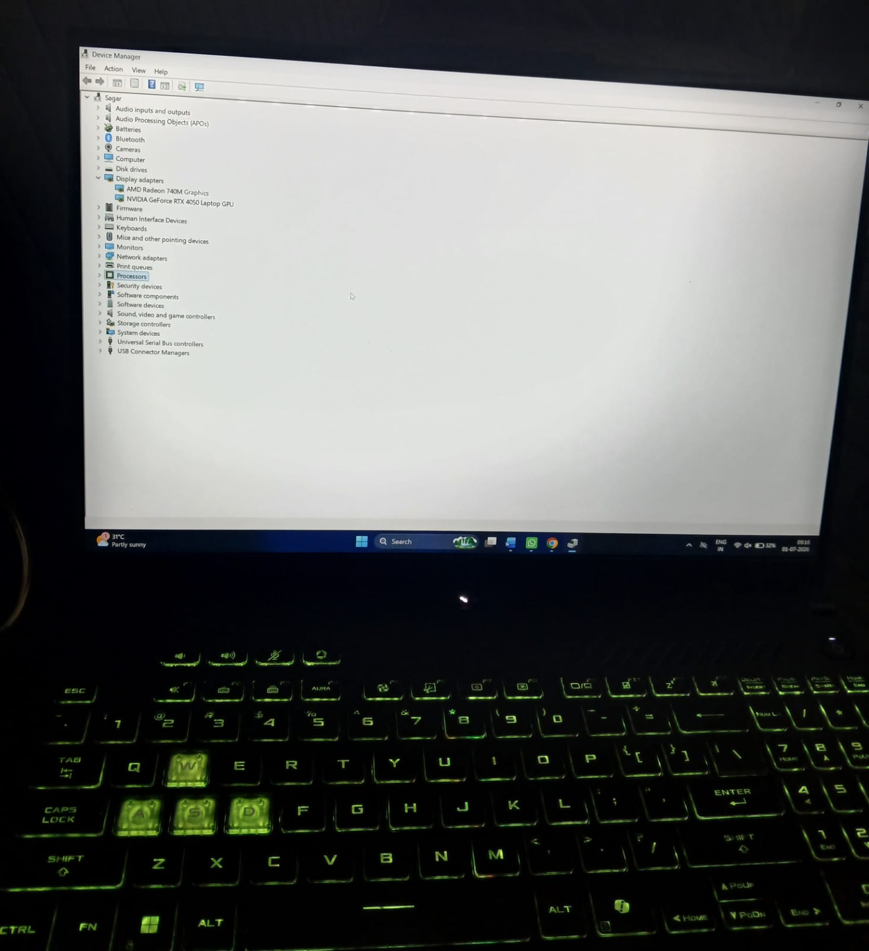

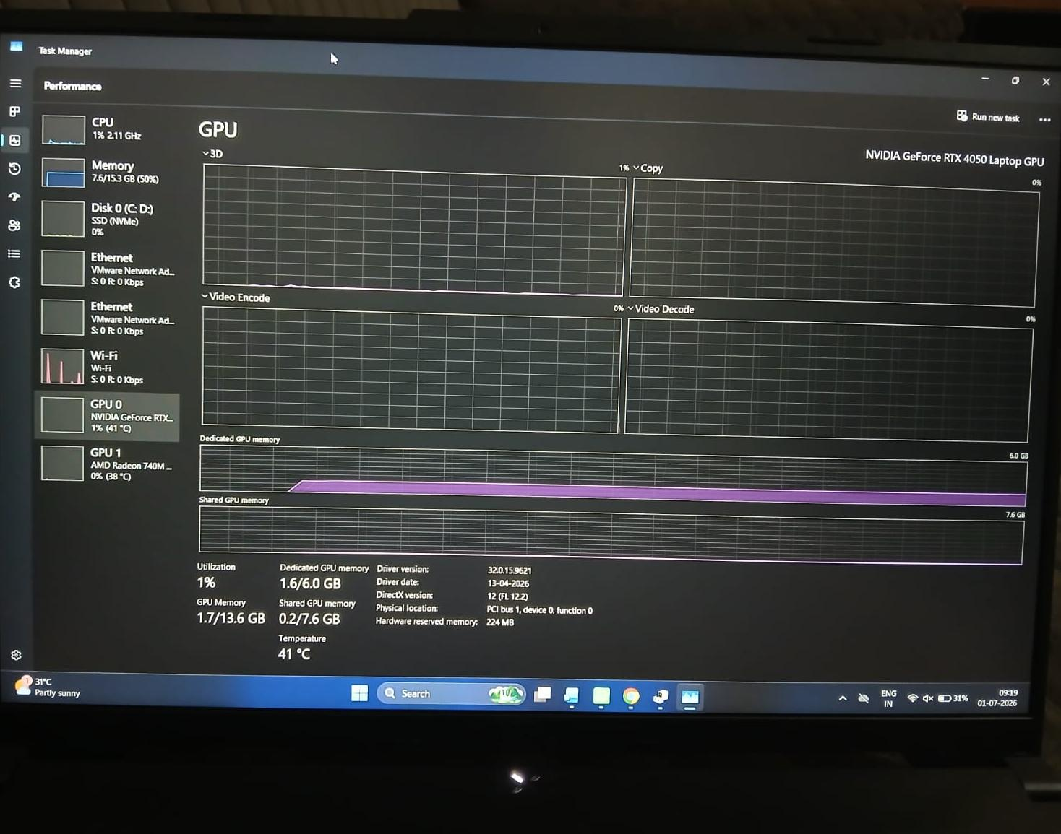

- GPU IDENTIFICATION – ASUS TUF GAMING A16

- Laptop Model: ASUS TUF Gaming A16
- Processor (CPU): AMD Ryzen 7
- RAM: 16 GB DDR5
- Storage: 1 TB NVMe SSD
- Graphics Card (GPU): NVIDIA GeForce RTX 4050 Laptop GPU
- GPU Type: Dedicated GPU
- Graphics Memory (VRAM): 6 GB GDDR6

- ABOUT NVIDIA GETFORCE RTX 4050

The NVIDIA GeForce RTX 4050 Laptop GPU is a dedicated graphics card designed for gaming, video editing, 3D rendering, and AI applications. It provides high performance and smooth gameplay at 1080p and can also handle many games at 1440p settings. It supports modern technologies like Ray Tracing, DLSS 3, and AI-powered graphics, delivering realistic visuals and higher FPS.

- FUNCTIONS OF GPU

- Renders graphics and visual effects.
- Increases FPS (Frames Per Second) in games.
- Improves video editing and 3D rendering performance.
- Reduces the workload of the CPU.
- Provides smoother gameplay and high-quality graphics.

- INTEGRATED vs DEDICATED GPU

Integrated GPU | Dedicated GPU
- Built into CPU | Separate graphics card
- Uses system RAM | Has its own VRAM
- Lower performance | High performance
- Good for office work | Best for gaming and editing
5. Lower power consumption | Higher power consumption

- MAIN USES OF RTX 4050

- High-quality gaming (GTA V, PUBG, Valorant, Cyberpunk 2077, etc.)
- Video editing (Adobe Premiere Pro, DaVinci Resolve)
- Graphic designing (Photoshop, Illustrator)
- 3D modeling and rendering (Blender, Maya)
- AI and machine learning applications
- Streaming and content creation

- WHY IT IS A DEDICATED GPU

The RTX 4050 is a dedicated GPU, meaning it has its own 6 GB GDDR6 VRAM instead of using system RAM. This allows it to process graphics much faster than an integrated GPU, making it ideal for gaming and professional workloads.

- CONCLUSION:

My laptop has both an Integrated GPU (AMD Radeon 740M) and a Dedicated GPU (NVIDIA GeForce RTX 4050 Laptop GPU). The integrated GPU is used for normal tasks and helps save battery power, while the dedicated GPU is used for gaming, video editing, 3D rendering, and other graphics-intensive applications. This combination provides both power efficiency and high performance.

- IDENTIFICATION OF LAPTOP COOLING SYSTEM

- INTRODUCTION:

A cooling system is essential for maintaining a safe operating temperature inside a computer. It prevents the CPU and GPU from overheating, improves system performance, and increases the lifespan of hardware components. Most gaming laptops use an Air cooling system with cooling fans, heat pipes, heatsinks, and air vents.

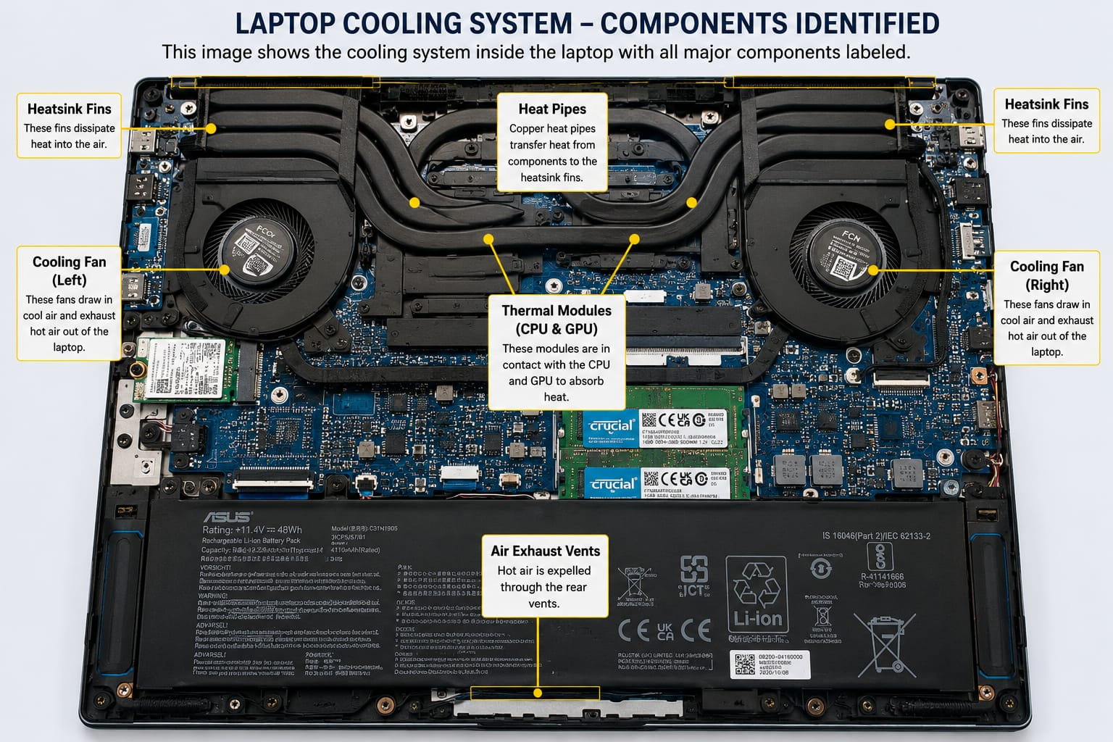

- MAIN COOLING COMPONENTS

- CPU Cooling Fan
- Cools the processor by blowing air through the heatsink.
- Prevents the CPU from overheating.

- GPU Cooling Fan
- Cools the dedicated graphics card (RTX 4050).
- Maintains stable gaming and graphics performance.

- Heat Pipes
- Transfer heat from the CPU and GPU to the heatsinks.
- Help distribute heat efficiently.

- Heatsink
- Absorbs and dissipates heat from the CPU and GPU.
- Works together with the cooling fans.

- Air Vents
- Allow hot air to exit and cool air to enter the laptop.
- Improve overall airflow.

- CONCLUSION:

The ASUS TUF Gaming A16 uses an advanced air cooling system consisting of cooling fans, heat pipes, heatsinks, and air vents. This cooling system keeps the CPU and RTX 4050 GPU at safe temperatures, ensuring stable performance during gaming, programming, and heavy workloads.

- COMPARISON BETWEEN AIR COOLING AND LIQUID COOLING SYSTEMS

- INTRODUCTION:

Cooling systems help maintain safe temperatures for the CPU and GPU, preventing overheating and ensuring stable performance. The two main types of cooling systems are Air Cooling and Liquid Cooling.

- COMPARISON TABLE
FEATURE | AIR COOLING | LIQUID COOLING
1.Cooling Method | Uses fans and heatsinks | Uses liquid coolant, pump, radiator, and fans
2.Cooling | Good for normal | Better for high-end
3.Performance | Gaming and daily use | Gaming and heavy workloads
4.Cost | Less expensive | More expensive
5.Maintenance | Easy to maintain | Requires more maintenance
6.Noise Level | Can be slightly louder under heavy load | Usually quieter under heavy load
7.Installation | Simple and easy | More complex
8.Best For | Office work, students, casual gaming | Professional gaming, video, editing, overclocking

- KEY DIFFERENCES

- Air Cooling uses fans and heatsinks, while Liquid Cooling uses coolant, a pump, and a radiator.
- Liquid Cooling provides better cooling performance for high-end systems.
- Air Cooling is cheaper and easier to install and maintain.

- CONCLUSION:

Air cooling is the best choice for most users because it is affordable, reliable, and easy to maintain. Liquid cooling offers superior cooling performance for high-end gaming PCs and professional workloads but is more expensive and requires more maintenance.

- CHOOSING THE BEST COOLING SYSTEM FOR A GAMING PC

- INTRODUCTION:

A gaming PC used for streaming live sports such as IPL matches and playing graphics-intensive games requires an efficient cooling system. During long gaming sessions, the CPU and GPU generate a large amount of heat. If this heat is not removed properly, the system may overheat, resulting in lower performance, reduced hardware lifespan, and possible system crashes. Therefore, selecting the right cooling system is essential for maintaining stable performance.

- MY CHOICE: LIQUID COOLING

I would choose Liquid Cooling for my gaming PC because it provides better cooling performance than traditional air cooling, especially during long gaming and streaming sessions. A liquid cooling system uses a pump, coolant, water block, radiator, and cooling fans to transfer heat away from the processor efficiently. This helps maintain lower temperatures even when the CPU and GPU are under heavy load.

Liquid cooling also reduces thermal throttling, allowing the processor and graphics card to operate at their maximum performance. It is quieter than many air coolers during intensive workloads and improves the overall stability of the system. Although liquid cooling is more expensive and requires careful installation, it is the best option for high-end gaming PCs.

- WHY I CHOSE LIQUID COOLING

- Provides excellent cooling for long gaming sessions.
- Maintains stable CPU and GPU temperatures.
- Reduces thermal throttling and performance loss.
- Produces less noise under heavy workloads.
- Ideal for high-end gaming, streaming, video editing, and content creation.
- Offers better long-term performance for powerful hardware.

- CONCLUSION:

For a gaming PC that will be used for streaming IPL matches and playing graphics-intensive games, Liquid Cooling is the better choice. It provides superior cooling efficiency, keeps the system stable under heavy workloads, reduces overheating, and helps maintain maximum performance. Although it is more expensive than air cooling, its excellent thermal performance makes it the preferred cooling solution for high-performance gaming systems.

- HIGH-END GAMING PC SETUP (RTX 5090 WITH LIQUID COOLING)

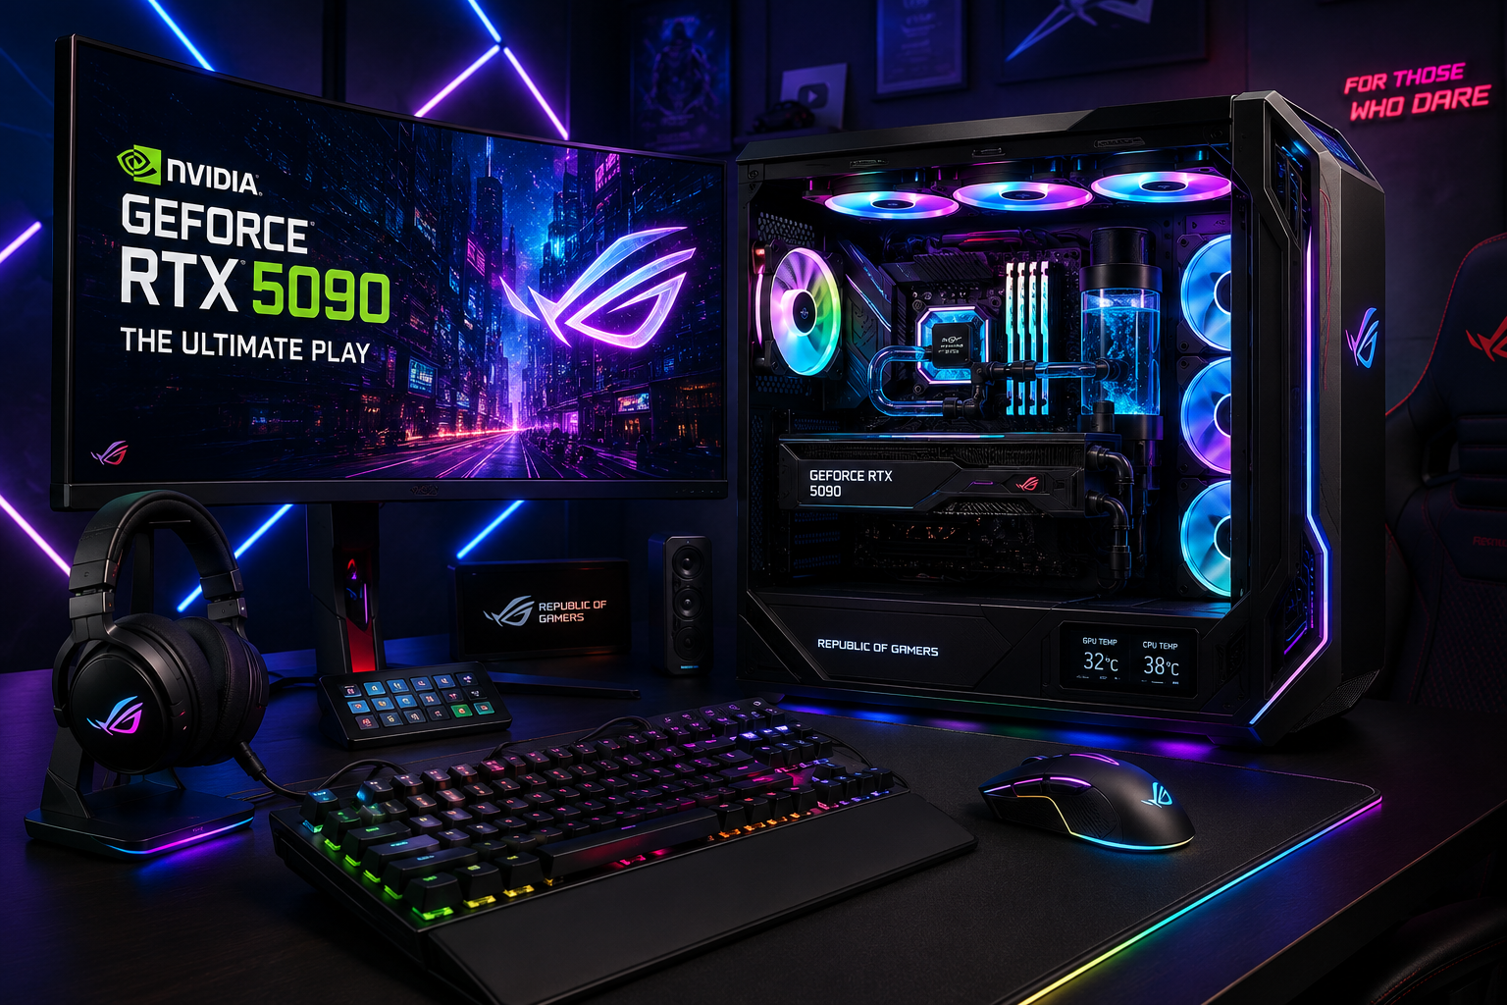

- High-End Gaming PC with NVDIA GeForce RTX 5090, Liquid Cooling System, RGB Mechanical Keyboard, Gaming Mouse, and Curved Gaming Monitor.
- Gaming specifications:

- GPU: NVIDIA GeForce RTX 5090 (Dedicated Graphics Card)
- VRAM: 32 GB GDDR7
- CPU: AMD Ryzen 9 9950X3D (or Intel Core Ultra 9 285K)
- RAM: 64 GB DDR5
- Storage: 2 TB NVMe SSD
- Cooling: 360 mm Liquid Cooler (AIO)

